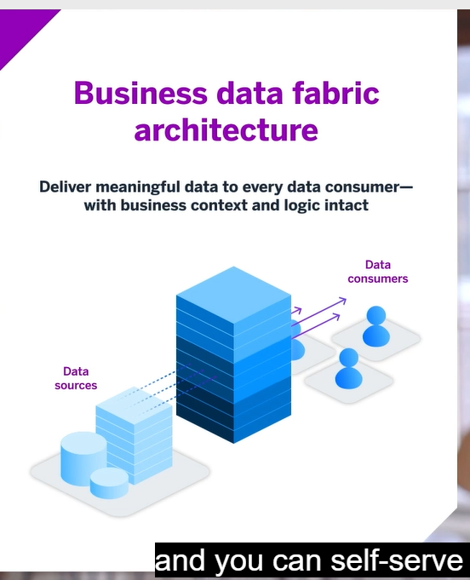

Data fabric is an integrated architecture built on SAP BTP that serves analytics, planning, intelligent data applications, data science and datalakehouse in SAP datasphere. Open ecosystem





Data governance layer: Robust with 3 critical capabilities data catalog, data privacy and data quality



Moving up layers from Governance to usage

Federated data access where possible in Datasphere and data replication when necessary

Final component of business data fabric are



